Tracking Business Finances

In business it is exceptionally important to track the money coming into and leaving your business or you will go bust!

Since you are pitching for investment, you will want to convince your investors that you have a sound financial plan and you can predict your future profits. To this end, we are going to use Microsoft Excel to create a software package to track this.

NOTE
It is really important that you backup your Excel files! It is advised that you use an easy cloud-based solution. The advantage of saving your Excel file in a Google Drive folder that is shared with your business colleagues is that it is always accessible by any one of them. You could also make use of Dropbox etc.

- Making Menus

1. First you should make a menu page for your tracking software. You can add sheets at the bottom of Excel and rename them like below;
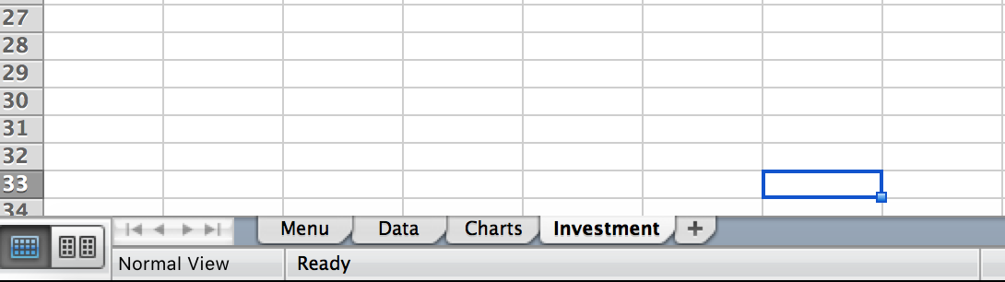

2. Then remove the Gridlines on your Menu page. This should be under the “Layout” menu item and you uncheck the Gridlines box;
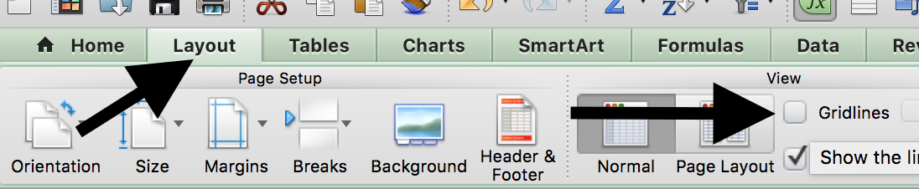

3. Next, you will create your buttons on the Menu page. These are just shapes in Excel, which you can find in the Insert- Shapes menus.

Note
Buttons should look professional as the whole software package you are creating should reflect your business. Think carefully about the colours and fonts you will be using- it would probably be a good idea to discuss this with your Marketing managers!
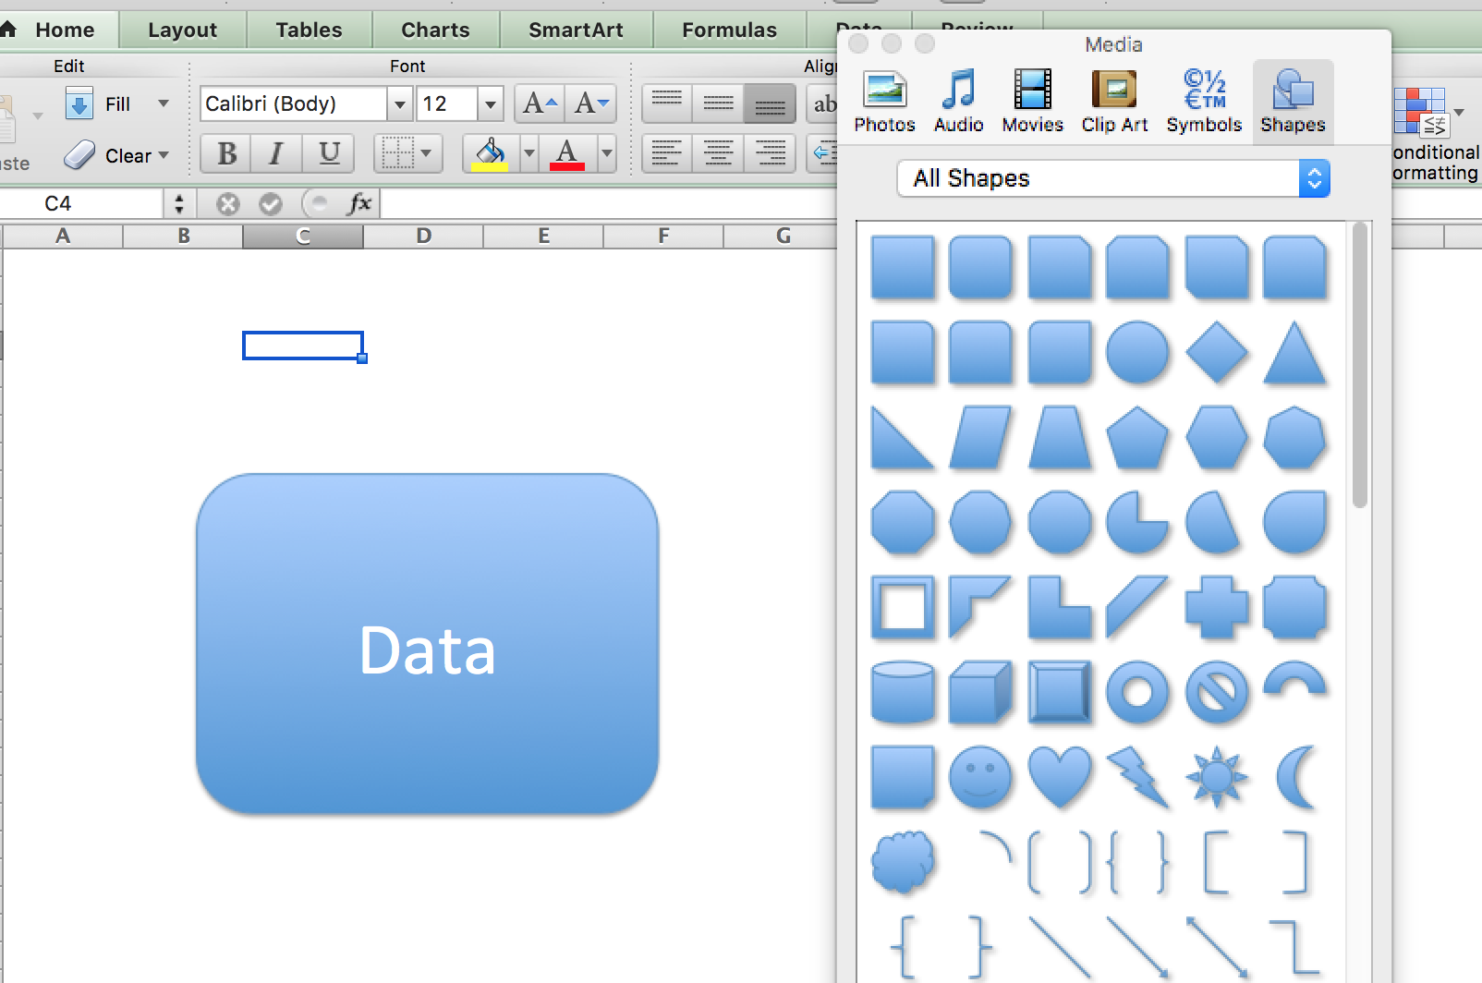
4. Once you have a shape, you can turn it into a button by right-clicking on it and selecting Hyperlink. This hyperlink should end in one of the sheets you made in step one. In the case of the example below, this button will take a user from the Menu page to the Data page.

1.  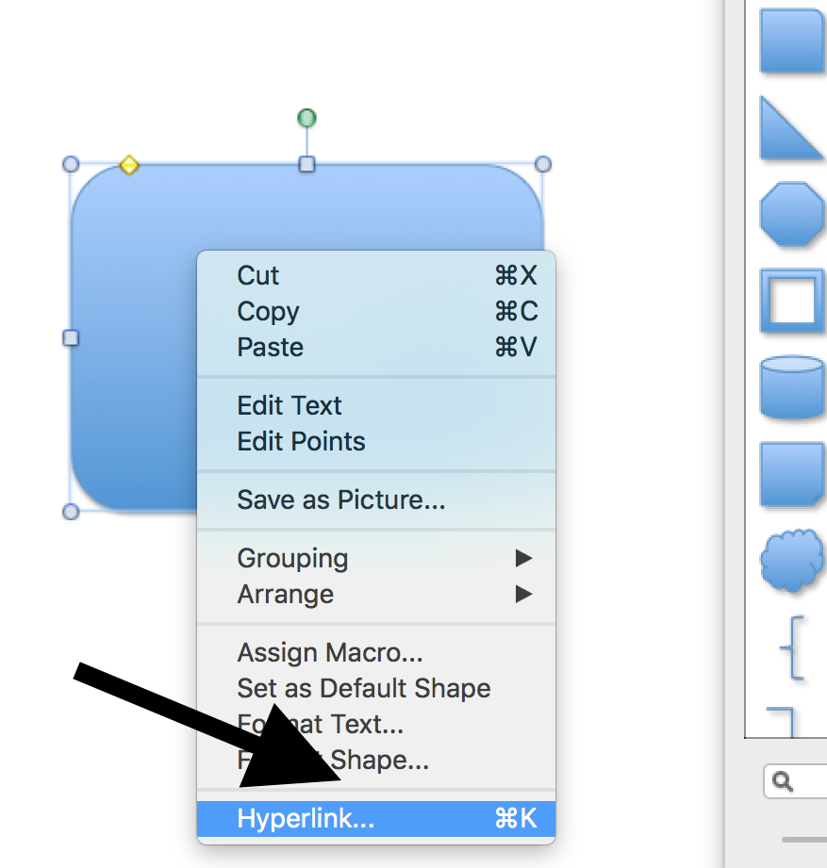 | 2. 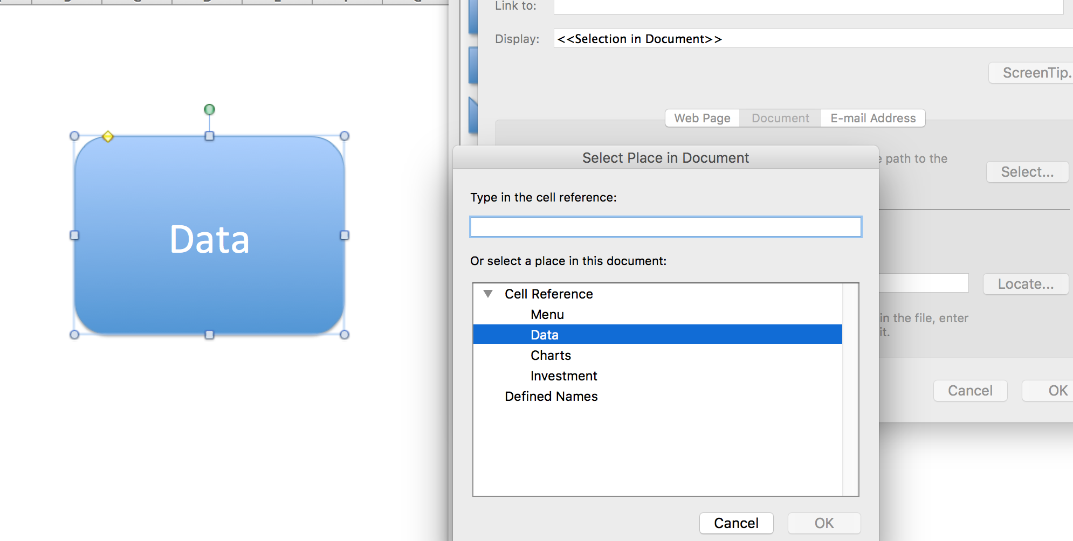

5. Once this is done, why not copy/paste the buttons to the other sheets and change the Hyperlinks to back to the Menu page?

You can be as creative as you want, but ensure the your Excel package looks professional! Here is mine below;

