12. Data Format, SUM and Functions

Now you will learn to start tracking all of your costs.

1. In the Data sheet of your Excel document in the “A” column, list all of the ingredients you will need in your product. Note their cost as a number (Don’t put dollar signs in!) in the “B” column next to it.
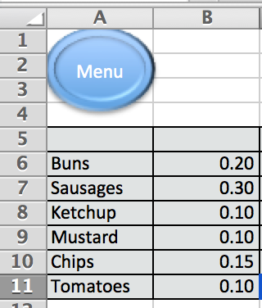

2. Now select all the cells in the “B” column. Right click and select “Format Cells”. Here you can choose the type of data Excel sees the numbers as. You can choose “Currency” and find $HKD. Ensure that you choose the decimal places most relevant.

1.  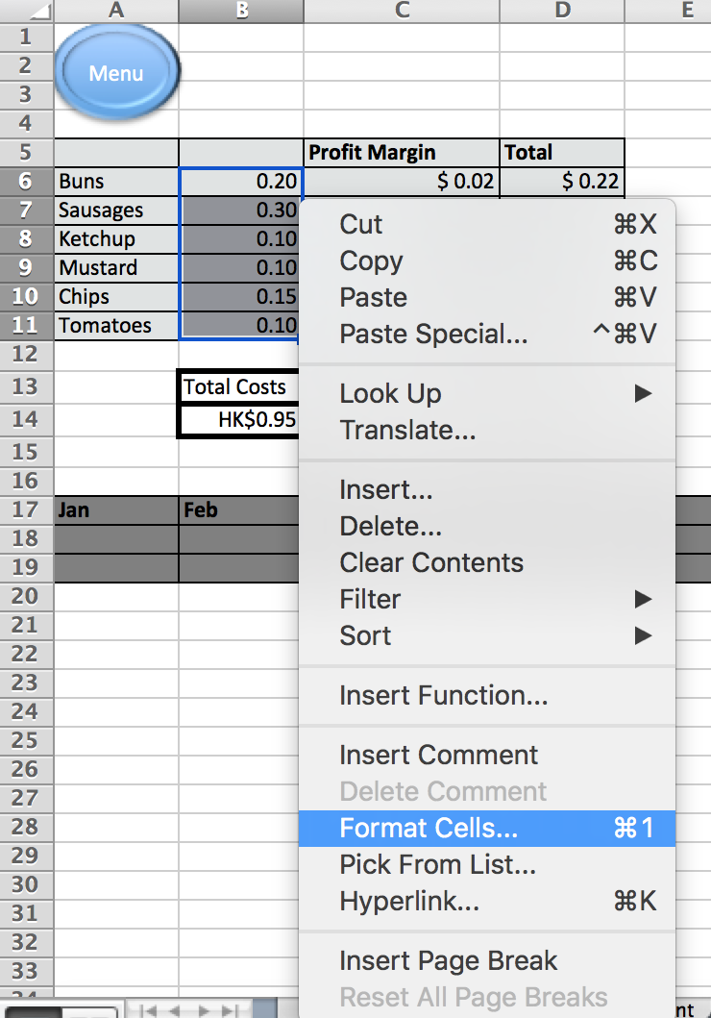 | 2.  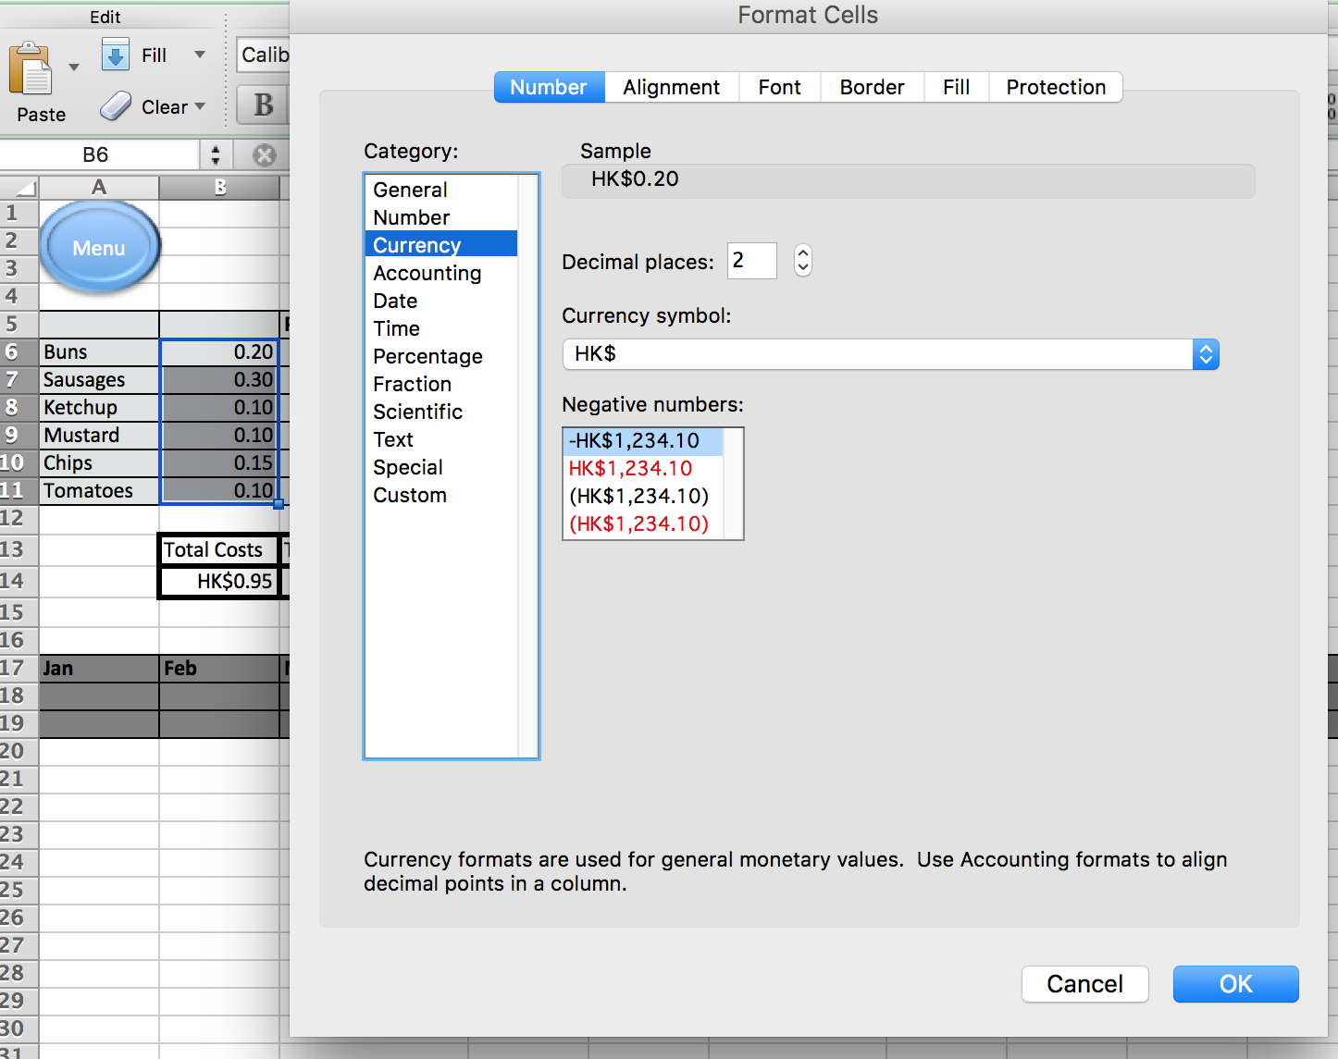

3. Now choose a cell a little away from the main table to use as your Profit Margin. A profit margin is the percentage amount of profit you will charge on each item. You can put in whatever number you feel is appropriate. In the example I have used 60%.
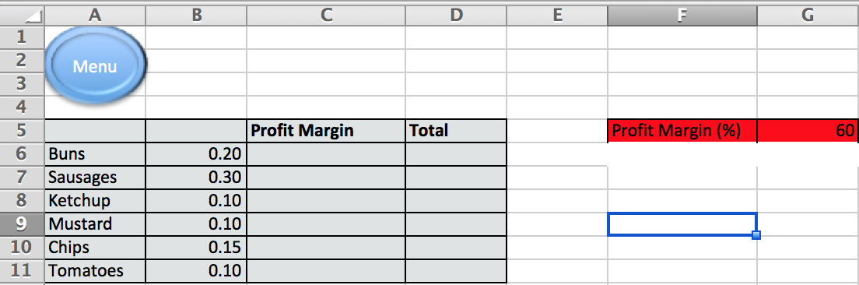
4. Working out Profits
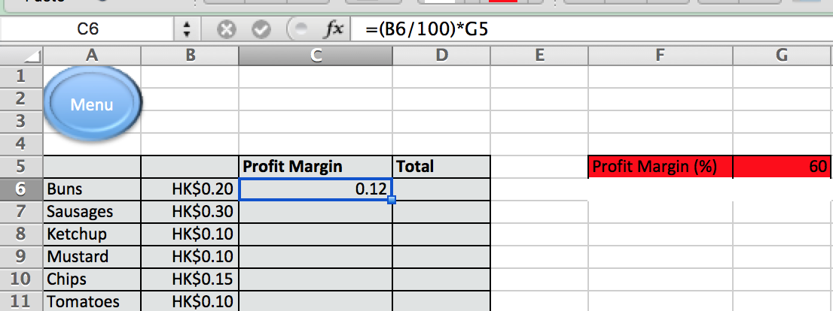
In the C column you can see the formula used to work out the profit margin applied to each item.Let’s break down the formula;

= | This shows Excel that arithmetic and logic is going to happen
(B6/100) | B6 is the cell reference and the whole bracket is looking to find 1%
*G5 | This is multiplying the 1% found in the previous part of the formula by the profit margin put in cell G5.

Adapt and copy the formula for the rest of the cells in the C column.

5. Now you want to find out the price of the ingredient plus profit by adding Column B and C together. For this we are going to use the SUM function. Check the formula in the screenshot below;
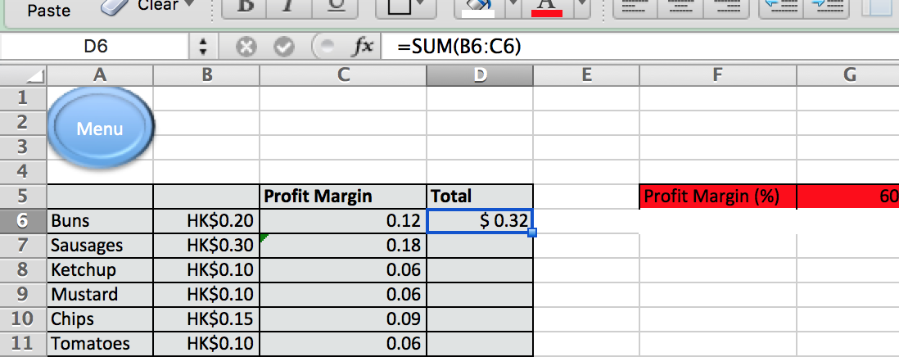

6. Using SUM function, write formulae working out your Total Costs, Total Profit and Total Price in the relevant cells at the bottom of your data table;
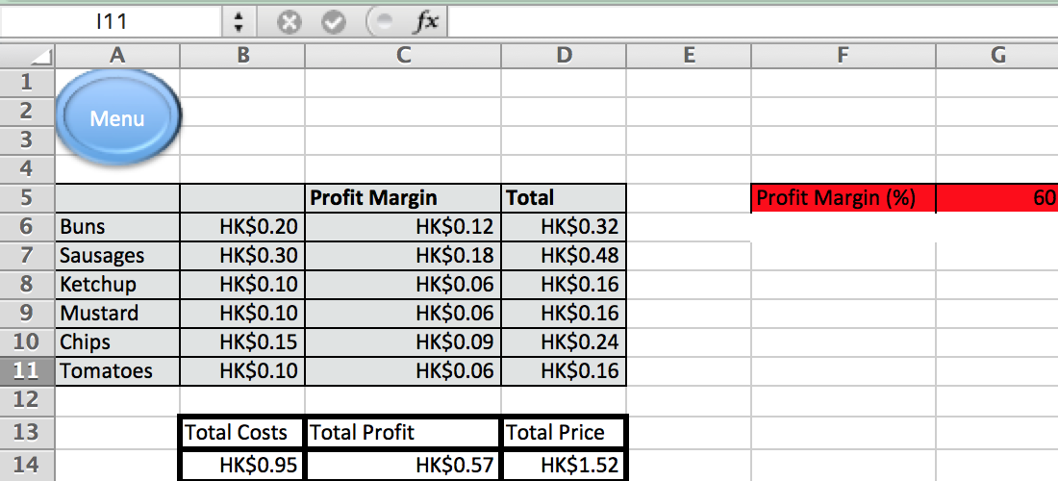

7. Format all the cells as either currency or numbers.

You should now be able to modify the Profit Margin cell and all the other cells should automatically update for the new figure. You should also be able to modify the prices and see how it affects your profits.

Check this useful Youtube tutorial to see some of these ideas explained.

