3. Investment of profits

Businesses generally look to make a profit- but what should you do with your profits?

It would be a good idea to have a clear plan as to what you are going to do with your profits- will they all go towards wages? Will some be used for advertising? What about Research and Development to make your product even better?

Referencing data in other sheets
1. List the things that you want to spend your profits on in column A of your “Investments” sheet. Note in Column B the percentage of your profits you wish to dedicate to each thing.

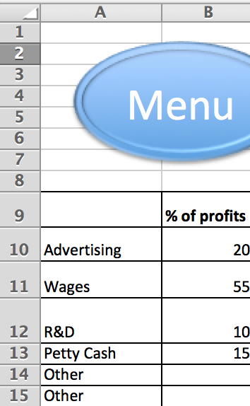
2. Next, you will need some data stored on your “Data” sheet. You could copy this manually, but Excel can do this for you! Look at the following formula below;
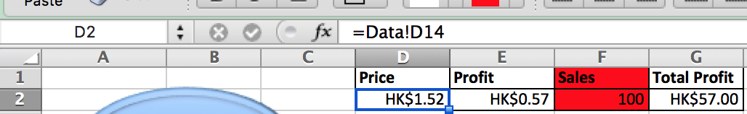

Let’s see what cell D2 is doing;

=Data! | The Equals sign tells Excel that some logic or mathematics is about to happen. This Excel document has a sheet called “Data”, this section (with the exclamation mark) is referencing that sheet.
D14 | This is the cell on the “Data” sheet that is being referenced. In this case it’s current value is HK$1.52. If that were to change on the Data sheet then it would change on this Investments sheet automatically.

Make your own version of the table shown above with the total cost of each product you make, the total profit you make on each one, the amount you have sold (make this number up for now- I have sold 100 in this example).

You should also use a SUM formula to multiply the number of sales by your total profit on each item sold to work out how much profit you have to distribute to wages etc.
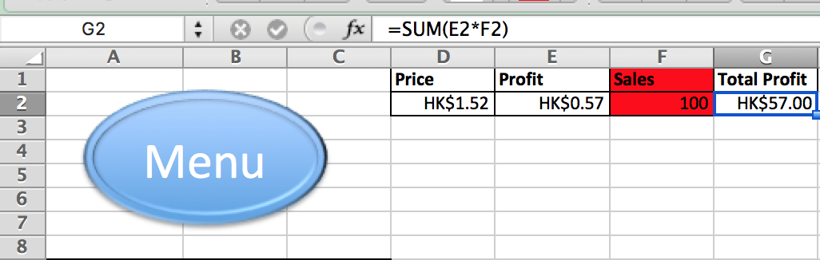

Now you can work out exactly how much money you get for the things you wanted to do with your profits. Look at the example below;
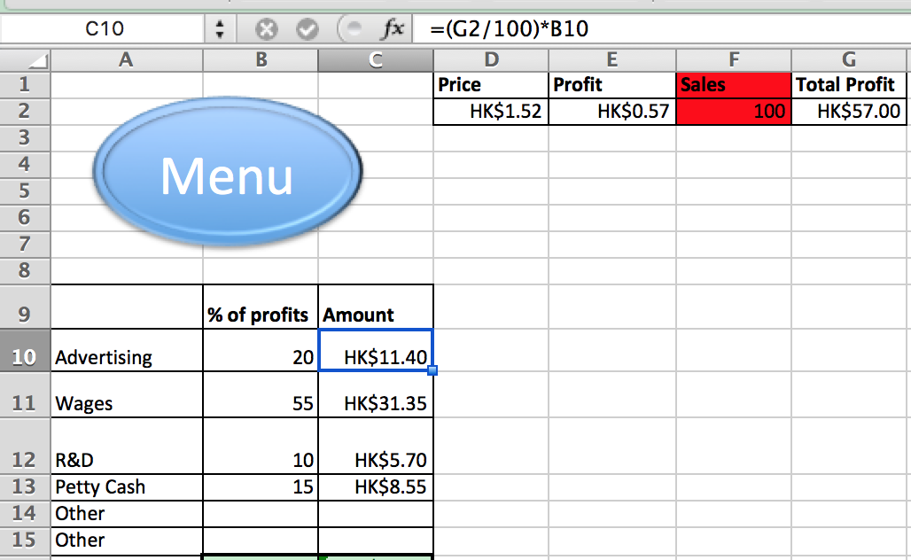

Conditional Formatting
1. It would be very bad if you spent more of your profits than you actually earned! Excel can tell you if you have over or under budgeted by turning cells a certain colour automatically. This is called Conditional Formatting.

Using the SUM function, calculate the total percentage of profits in column B (This should add up to 100!)

2. Click on the cell and use the Format- Conditional formatting menu. It should look something like this;
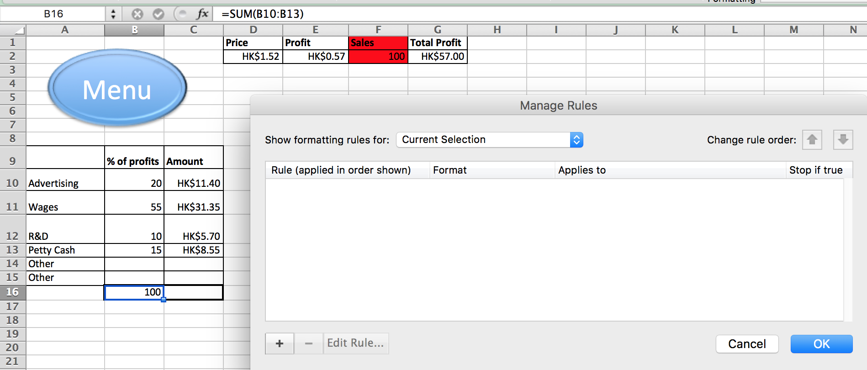

Click the plus sign to add a rule and choose “Classic” as the style. Look at the example below;
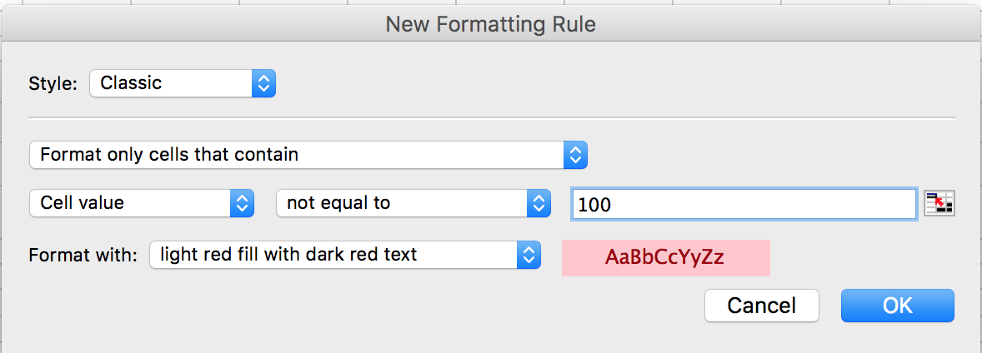
“Format only cells that contain” means that only the cells you selected will have the formatting.
“Cell value” means that the formatting rule only applies to a number
“Not equal to 100” means that if any other number other than 100 is in the cell the following change will happen...
“Format with: light red fill with dark red text” will mean the cell changes to red.

Remember - this rule will let you know if your percentages do not add up to 100% by turning red, but if you want it to turn green when it does add up you must add a second rule!
