4. Charts and visualising data

Pitching for investment can be a scary thing where you have to confidently convey a lot of information relatively quickly to an audience. It is not advisable to start showing Excel data tables as this is simply too overwhelming for an audience to process during a sales pitch!

Charts are the best way of demonstrating what data looks like to an audience in a meaningful way. The example below will show you how to make a simple chart showing the breakdown of our costs for each product.

1. In your charts sheet, remove the Gridlines for the page to make it easier to read. This should be under your Layout menu and be a checkbox.

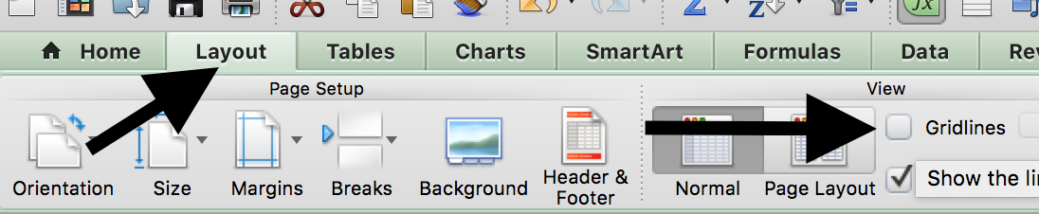

2. Now select the type of chart you wish to insert. If you can’t find the menu, look for the Insert menu and select chart. For this example we will use a simple pie chart - it is advised to keep charts simple to make them as clear and readable as possible.

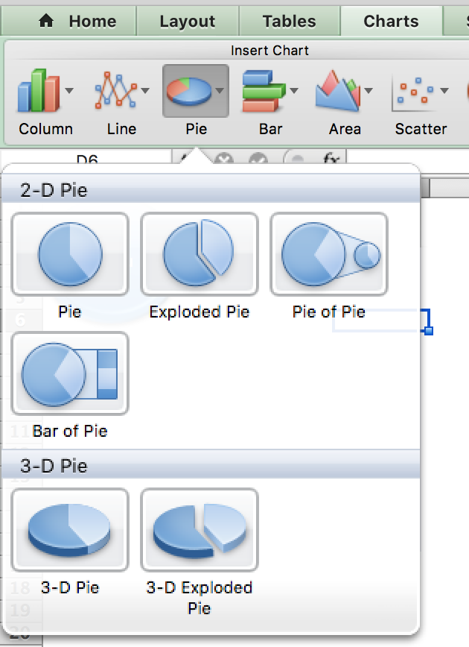

3. Excel will then ask where you wish to put the chart and how large you want to make it. Once you have done this, right-click on the area where the chart will appear and click “Select Data”
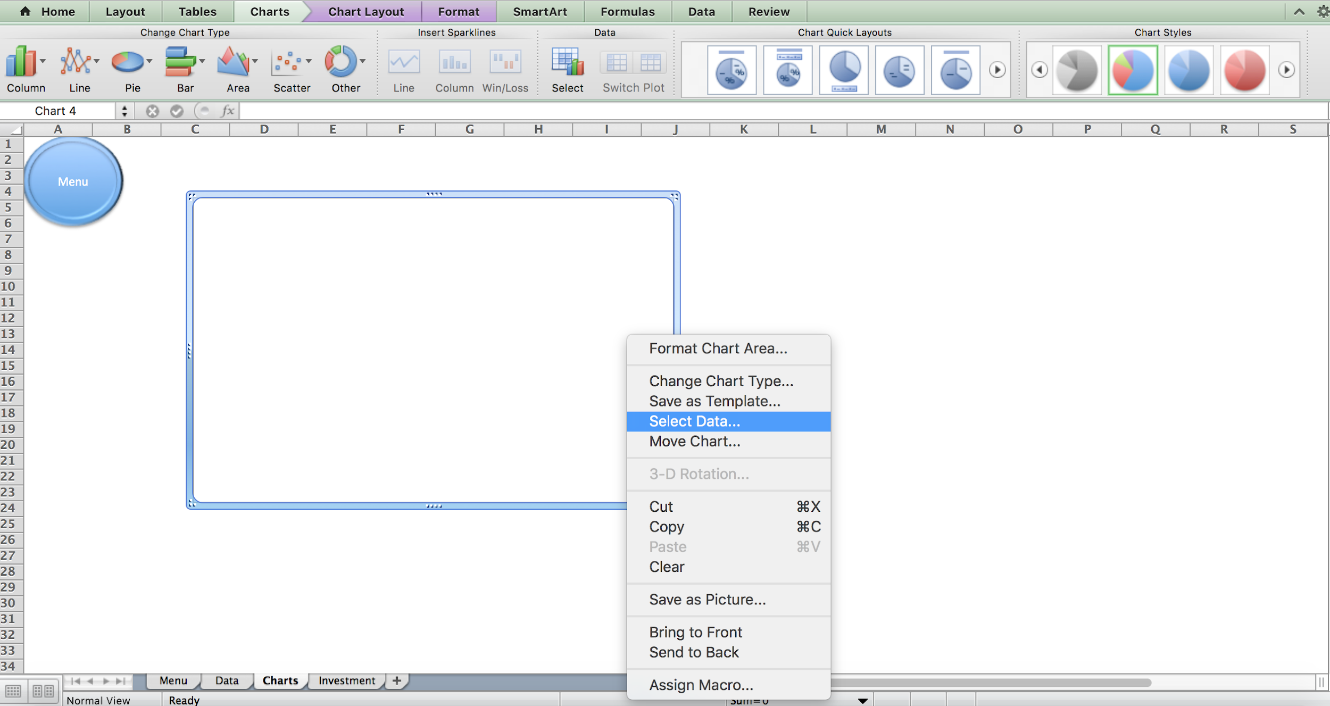

4. Click the button next to Chart Data Range and select the data you wish to chart. Note - you don’t need to select the chart headings, just the items to be added to the chart. In this case it is Column A and B of the Data sheet;

1.  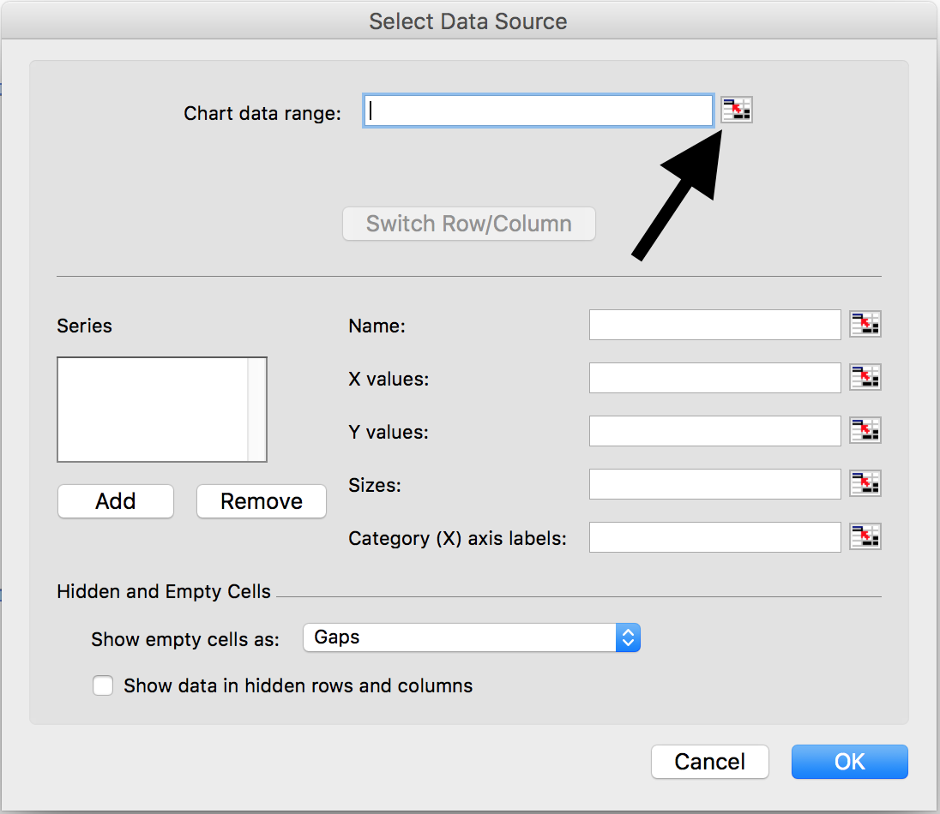 | 2.  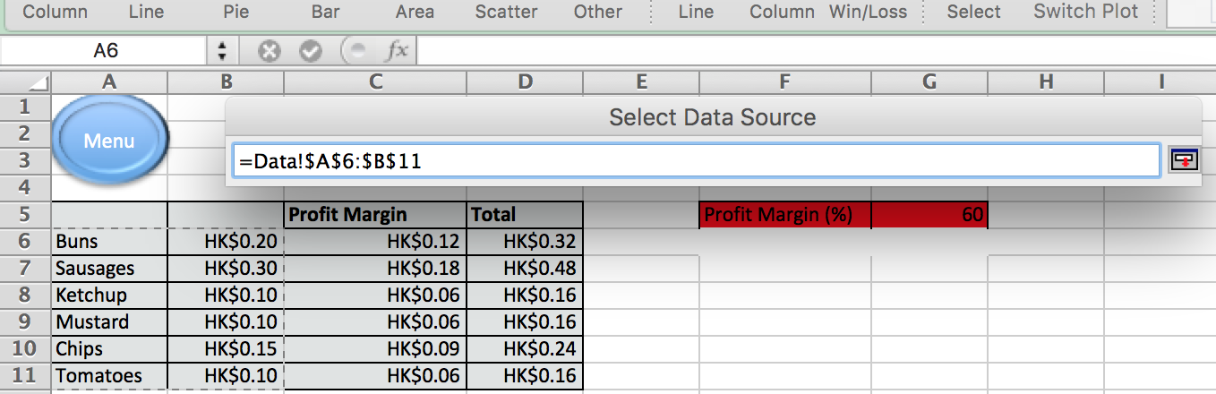

5. Once you have selected your data you can add a title to it and Excel should have your chart for you;
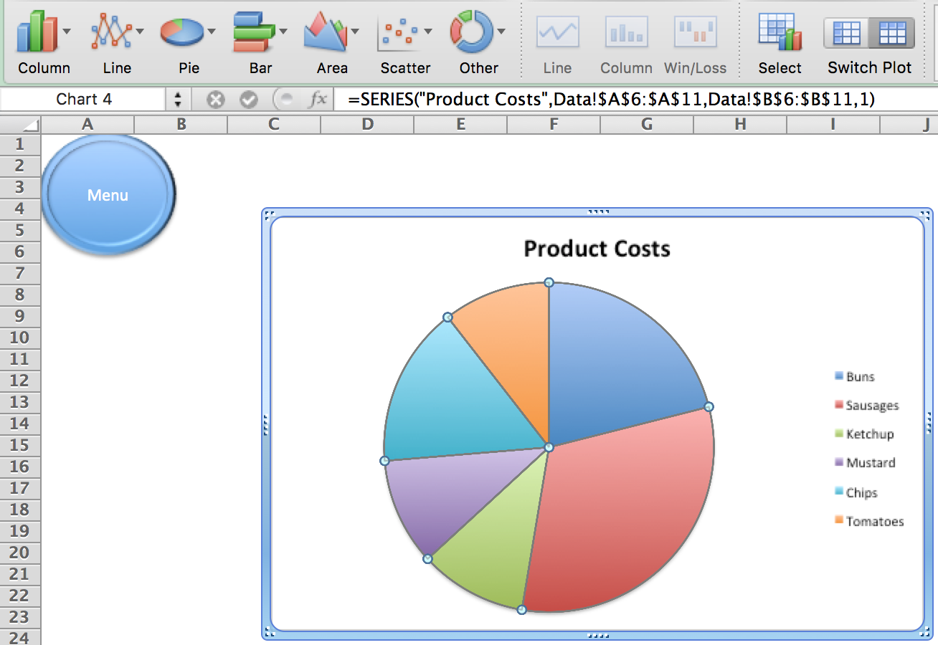

6. You can edit your chart to make it look better through adding data labels, changing borders, text, font etc. Just right-click on different elements of the chart to see options.
Here’s a great Youtube video on creating charts that might help

