5. Data Validation & Protection

Data validation is a really useful tool in Excel that can be used to prevent mistakes and set rules for data. Essentially it is a rule for a cell so that the wrong information cannot be entered.
An example might be a cell that must only have numbers greater than 0.01 be put into it- perhaps like currency. If a price lower than this (0.00) is entered, a message pops up explaining what the issue is.

1. First, format the cell to the type of data you want (the cell below has been formatted as currency). Click the data validation menu under the Data menu.

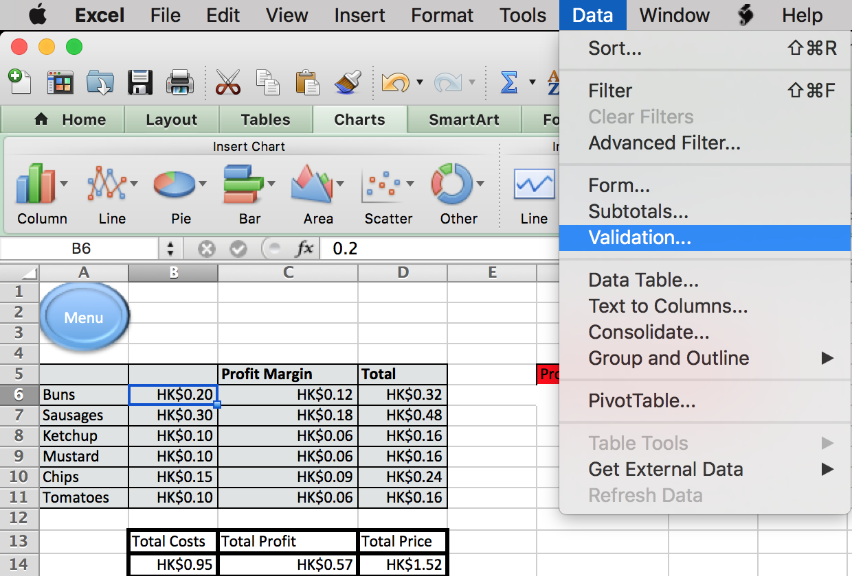

Enter your rule for the cell- in this case the rule will be that the number in the cell must be higher than 0.

1.  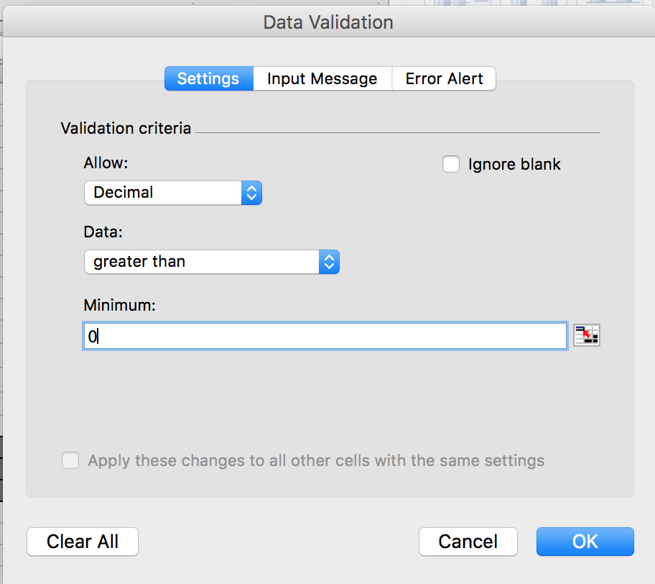 | 2.  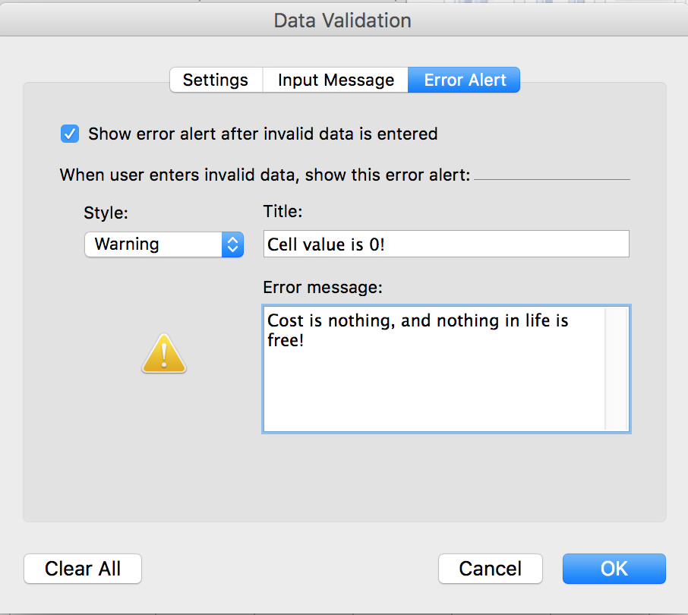

As you can see from Box 2 above, an Error alert will be shown in the cell contain the value 0.

2. Test your rule - put the value you made a rule about in the cell. It should show the Error message you set;

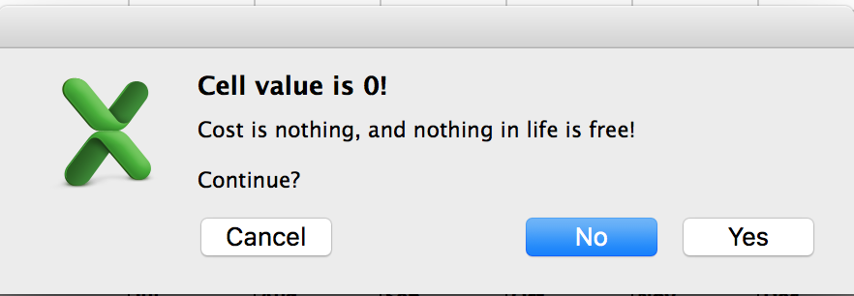

3. Protecting a sheet is also important if you do not want the data to change. To do this use the Tools- Protection Menu;
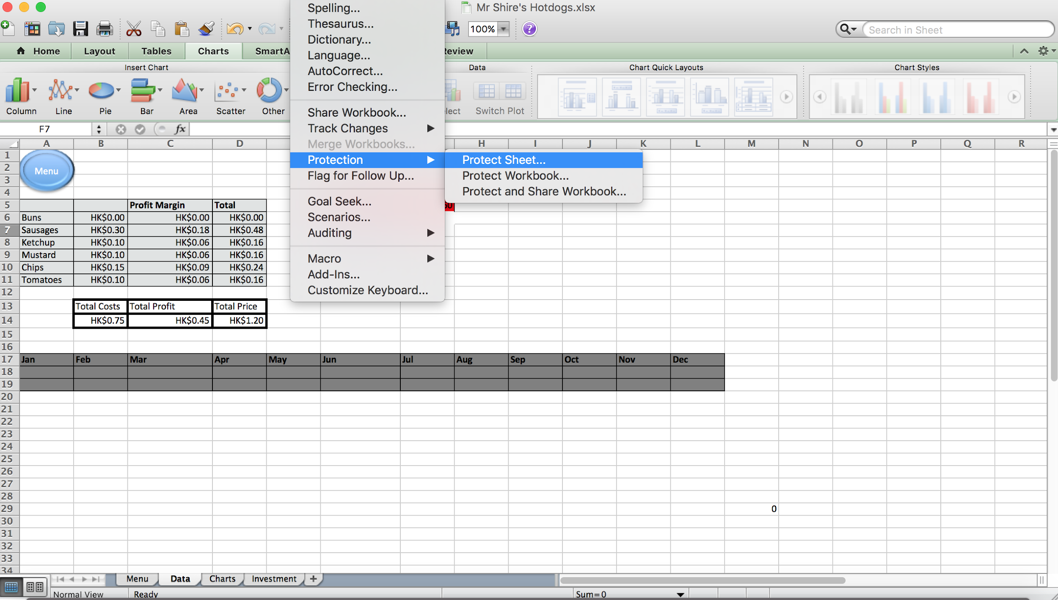

Here you can set password options and allow users certain rights. It is advised that you DO NOT set a password that your group does not have access to as this will likely cause problems.

4. Once you have enabled protection, you can protect different elements of the sheet. Please be extremely careful here as you have the ability to completely break the Excel document!

Find out more about locking and unlocking sheets here.

