Business Plan Outline:

- Set the purpose for your company.

Purpose: Goals keep everyone focused and headed in the right direction. Purpose-driven companies deliver a meaningful “impact” on their customers, employees, the society and the environment.

Examples:
The purpose of Unilever Ltd is to “make sustainable living commonplace”.
The purpose of Tesla Motors is to “accelerate the advent of sustainable transport by
bringing compelling mass market electric cars to market as soon as possible”.

- Company Values, Vision and Mission
A company’s values, vision and mission form the core of its business.

Values: A company’s value system is the ethical behaviour standards to which its employees will hold themselves and their colleagues accountable.

Examples:
The corporate value of Google are an essential element of the company’s culture. Their first value is to”Focus on the user and all else will follow”. The company focused on providing the best user experience possible. Next, “It’s best to do one thing really, really well”. They focus on their strength in solving search problems. Third, “Fast is better than slow.” Google strives to ensure the efficiency in their serving environment.

Vision: A company vision generally represents the desirable future - where the company wants to go and what it wants to be. In many ways, it is the company’s dream.

Mission: A mission statement is a concrete plan that describes how to accomplish the company’s vision. Mission statements clearly explain what a company seeks to accomplish day to day and over the long term.

Examples:
The vision statement of Amazon os “to be earth’s most customer centric company”. Its mission statement is to “build a place where people can come to find and discover anything they might want to buy online.”

3. Corporate Social Responsibility (CSR)

CSR is widely practiced in the business community in Hong Kong SAR. However, CSR to some companies is synonymous with philanthropy and to some it is a brand-building tool. The company is obliged to give back to society.

Consider the following:

i. purpose - creating a meaningful impact on the lives of your customers, employees and other stakeholders is important for a sustainable business
iii. profits - constantly innovating to create value for the shareholders
iii. corporate governance
- behave ethically in all your business operations
- protect the interests of shareholders by providing complete and accurate financial
statements and reports to all shareholders
iv. employee well-being - improving internal communications, working conditions and
supporting staff development
v. environmental protection
- promoting environmentally friendly products or services, encouraging environmental
protection, waste reduction, or recycling in company operations
- creating a product/service that can solve an environmental problem
- promote rational use of resources; use recyclable packaging
vi. Social value - delivering direct and indirect benefits upon society by not just giving back but also generating profits for the business by doing good to the society (e.g. health and wellness innovations, knowledge dissemination and sharing, creating employment opportunities for the underprivileged, preservation of culture, etc)

4. Company structure
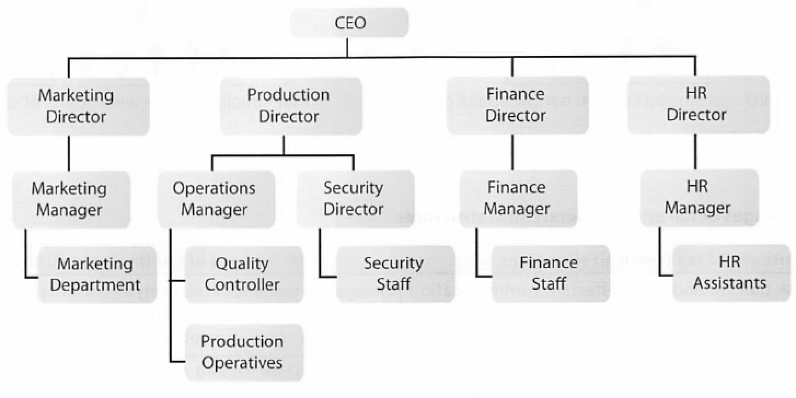

5. The business model
Every organization needs a business model to help answer the five basic questions of any business.

WHO - who are the customers and where can they be reached?
WHAT - what do they need and what values can the company create in meeting the need?
WHY - why do they need it and why should the company be the one to satisfy the need?
HOW - how to produce the product or service or both to meet the need?
HOW MUCH - how much will it cost to produce and how much return (benefits) can be received in producing it? (the “how much” problem is not just economical but social and environmental)

Presentation:
As a group you are required to create a group presentation that is engaging and shows your product and how you aim to achieve success in selling your product.

The style of presentation is entirely up to you as a group. It should highlight some of the elements of your business plan.

