Year 7 Hong Kong House Price Investigation

In this investigation we are going to analyse the prices of homes in Hong Kong. To begin with, we are going to break Hong Kong down into 4 areas as shown on this map. These areas will be; Hong Kong Island, Kowloon, The New Territories and the Outlying Islands (mainly Lamma and Lantau)

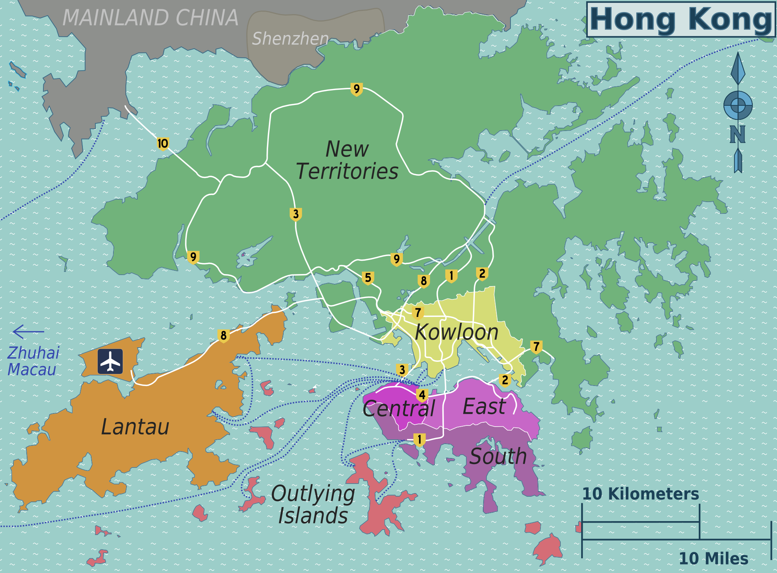

We will also be using a real estate web site. The best one (obviously) is one that tests your ability to understand data from a map. https://www.spacious.hk/en

What we are aiming to do is complete the table at the bottom of these instructions with the numbers of houses we can find in Hong Kong at different price ranges. This will give us a better understanding of the price and number of houses in the different areas.
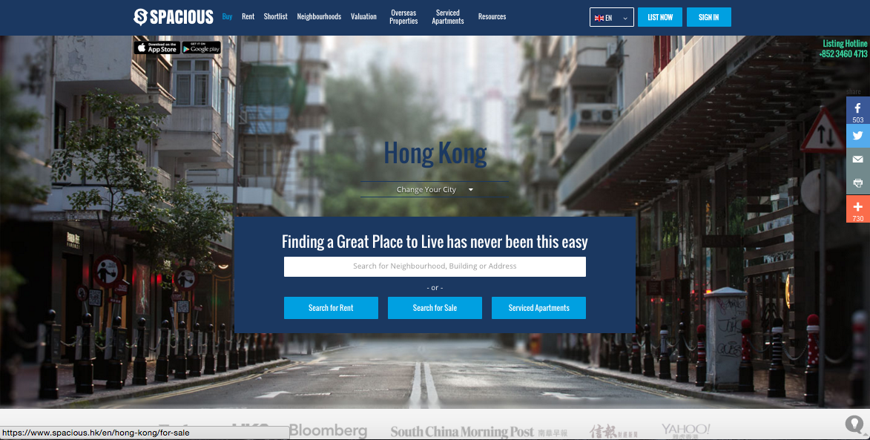

First some instructions about using the website.

1) Click on “buy” at the top left of the screen (in the red circle). This will take you in to a screen with a map of Hong Kong with all of the properties listed for this site. It looks a little bit like the screen shot on the next page.

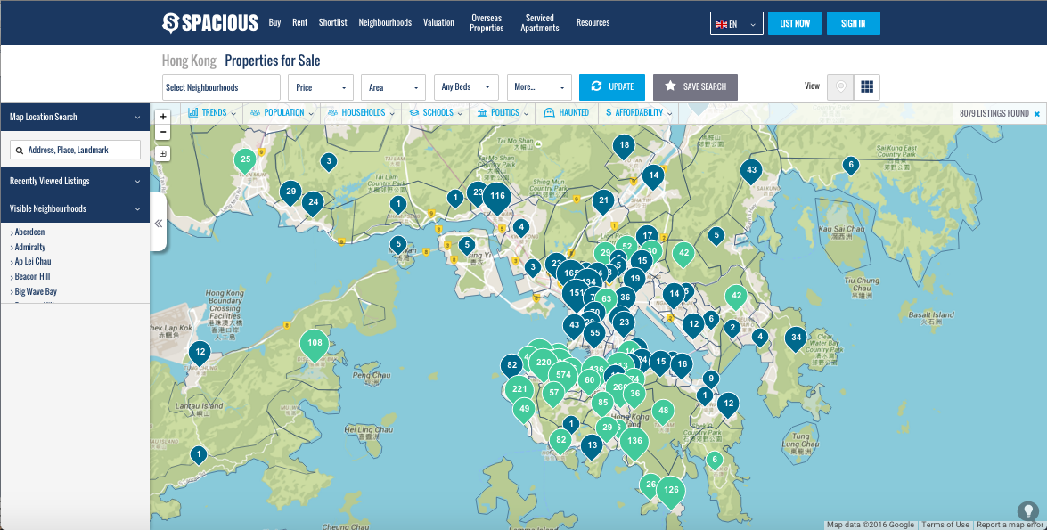

The bubbles show you how many properties there are in that area and if you hover your mouse over any of the bubbles it will tell you the district they are in. The map works like Google maps so you can zoom in and zoom out the same way.
2) Make sure you zoom out so that you can see the whole of Hong Kong. At the moment there are too many properties for us to search, we’d be here for several days. So we’re going to add a filter.

3) Click on the “price” box (also in the red circle). Two new fields will drop down. One that says “minimum” and one that says “maximum”. We will be entering different information in to these fields to complete out investigation.

4) We will now complete our first search. In the minimum box type 200 – it should give you a figure of 200M HKD. Leave the maximum box blank.

5) Now press the update button (highlighted above by the yellow circle)

6) The map is now showing us all off the properties for sale that have a value of over 200 Million. Your job is to add up the numbers in the bubbles shown in each of our 4 regions and then input these numbers in to our table at the bottom of this sheet. These will go in the HK$200+ column.

7) In this investigation, the area we will count as Kowloon is shown on this screen shot. Anything else is the New Territories unless it is one of the islands.
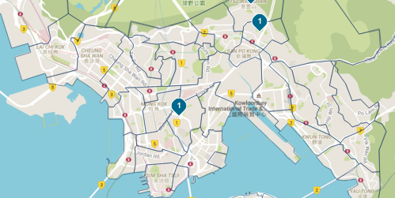
8) You can use the maximum button in the same way. So, for searching properties between 175 and 200M HKD you just type 175 in to the minimum and 200 in to the maximum

9) You now have to go out and find the data for the different price ranges

10) Once you have filled in the data for the first search, the next search is 150M HKD – 200M HKD. Type 150 in the minimum and 200 in the maximum boxes and then press update. You may have to zoom in to add the number of properties in the bubbles so remember that every time you press update you have to zoom out to see the whole of Hong Kong.

11) When you have researched the top 4 brackets, we will then look at the cheaper housing available in Hong Kong. For the first you leave the minimum blank. The rest you should know what to do!

 |  | Hong Kong Island | Kowloon | New Territories | Outlying Islands
High Priced | Number of properties HK$200M+
 | Number of properties HK$150M – HK$200M
 | Number of properties HK$100M – HK$150M
 | Number of properties HK$50M – HK$100M
Lower priced | Number of properties  up to HK$2M
 | Number of properties HK$2M – HK$2.5M
 | Number of properties HK$2.5M – HK$3M
 | Number of properties HK$3M – HK$3.5M

12) With the information you have collected in this table. Write 2 paragraphs on the information you have found. Comment on the areas that have the highest housing prices and the areas where you are most likely to find lower house prices. You can also mention your initial ideas about wealth in Hong Kong. You can also comment on the research we have done. Can we use it to form ideas about Wealth in Hong Kong or do we need to know more or different information?

