InveStig8: Student Guide

Year 10 Independent Research Project
Spring Term 2017

InveStig8: Key Questions
What is the InveStig8 Project?
This project is an independent research project that you will write in the style of an investigative article. It is designed to introduce you to some of the ideas and content you will be studying in your Diploma subject for I&S and also to give you skills that will be useful in all subjects at diploma level. You can choose the focus of your study and the subject themes it connects to. The focus can and should be a topic of interest for you, so you will have a head start on understanding it and will enjoy finding out more about it.

Why are we doing this?
The project is designed to expand your skills in a lot of different areas. As a long project it will be a test of your organisation skills and you will need to plan out your project to complete it successfully. You will also learn more about how to find resources for researching a topic and the correct way to use them in your work, for example; how to reference sources of information. You will learn how to set yourself a question and answer it and you will further develop your skills of Analysis and Evaluation that you have been learning in many of your subjects during Year 10. You will learn how to include structure into a longer piece of writing, will need to think about how you use images and graphics to enhance your presentation and you will have to look back over your work to review and edit it, to make sure you score the highest possible marks for your final piece. But the real answer is that all of these skills will be a great help to you in your Diploma level of education. So this is a real opportunity for you to learn skills today that will help you gain higher examination scores.

How long does it have to be?
We want this to be a detailed and in-depth piece of writing, but at the same time we want you to think hard about what information to include and what information to leave out. Therefore your target is to produce an article between 1200-1500 words. This should make you have to think hard about how to fit in all of the information your have researched, so you will have to be selective.

How much time do we have?
Starting from This week you will have around 5-6 weeks to start, research, complete and present your project. You will have all of your I&S lesson time to work on researching or writing your project, or completing your journal (which has the assessment criteria written out for you). Some of the lesson times will be spent having tutorials from your teachers. You may wish to spend some time out of school working on your project. There should be a good amount of time to complete this assignment in class, but you will need to be focused and manage your time well. No additional I&S homework will be set that is not related to completing this task, although your teacher may recommend deadlines to keep you on track. Since this project is based on your own interest, occasional activities such as reading related websites, magazines or books, or watching documentaries should be quite interesting but not intense.
InveStig8: Timetable
Below is a rough outline of the way that we will be progressing the projects. The highlighted areas will be the themes of each week and should run alongside the area in your project that you should be giving focus too. If you are ahead, you can research these by yourself and use the tutorials to cement your understanding of these things. If you are behind, you should think of trying to progress your project to catch up with the tutorials and themes as they are presented by your teacher. This should help you finish your project on schedule.
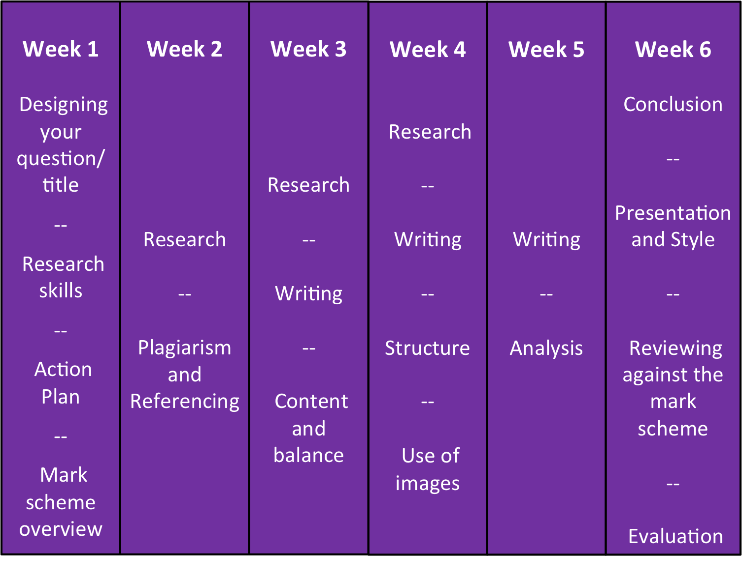InveStig8: What do you need to do?
The timetable above should give you a good early indication of the different areas you will need to think about for your project. Outlined below are some details about the teacher tutorials that will be taking place in the sessions.

Topic Checking - Deciding on your research focus and choosing a title.
This is one of the most important parts of the project, so it is vital to take some time to get it right. You should choose a theme that is of interest to you in some way and try to link it to the different subjects using the InveStig8 matrix. Your teachers will help you to do this and suggest possible ways that you can include different themes, but you will have to do some research yourself to identify the best possible route for your investigation to follow. You should try to form your title as a question that you can explore within your writing. Don’t be worried to approach other I&S teachers if they are specialists in the area you are studying.

Planning and organization
You will need to plan and organize yourself to complete your article on schedule. Leaving everything until the last day on a project of this size will result in frustration and a lot of frantic last minute panic. It is important that you set deadlines and identify key aspects that you need to complete by certain days or periods in your Action Plan. You may find you don’t keep exactly to all of the deadlines in your Action Plan, but you should learn a lot about what you can achieve within certain timescales. To help you, you can use the action plan in the Investig8 Journal document. Download a copy of this and save it. You may get ahead or fall behind during the course of the project but having a plan to work to will help you keep focused on completing it on time.

Research skills
Having grown up in the internet age you may be thinking that there is nothing you can be told about researching information, but the internet is not as simple and reliable as we think. Finding a piece of information on a web site is only the start point of your research. From here you need to ask a lot of questions, for example; How reliable is this information? Who wrote this information? When was it written? What has been written since that might change my outlook on this subject? Is this the only viewpoint on this matter or are there other people with different views? Where you take your information from is also important. Whether it is from a book, a news website or someone’s personal blog can have a big impact on how accurate and reliable the information is.
The internet alone is not the only source of information. There are also amazing things called books, which can also be used to shape your research. In fact, seeking out relevant books, articles from the library may be the best way to focus your choice of topic in the early stages of the project. In addition, we also have access to on-line databases through the school library and subject specific journals and magazines that may have articles and a lot of relevant information in them. Don’t just rely on the internet!

Avoid plagiarism and reference your work correctly
You have now long since left the stage where you can cut and paste information from the internet. Your completed work will be submitted to a plagiarism checker called www.turnitin.com which can instantly identify if the work you have submitted is your own or has been copied and pasted into your article from another source. In IB projects, if you submit work that is plagiarized you are likely to score 0 for that piece of work and may be entirely disqualified from that subject. However, here is the good news! You can still copy and paste information into your work if you accurately identify where that information comes from and if it is used correctly to progress your own discussion. This project is a great chance for you to learn and practice the skills of correctly referencing information.

Learning from the process
We want you to learn how to do longer projects well, so as you go through your investigation you will also be keeping a record of your action plan (which doesn’t need to be perfect, which is why we’ve added the amendments column. This can be the start point for your evaluation, where you will need to write about the difficulties of writing, finding data/information, how well you are sticking to your plan and any adaptations you have had to make, the challenges you find as you go through the project, the things you found easier than expected and so on. When the article is complete you will be completing your evaluation to understand what you have learned about doing long projects.

Writing a good article
One of the main aims of this activity is to enhance your skills in producing good quality longer pieces of writing. To do this you will need to think hard about the content of your article, what information you are putting in and how it relates to your question and the themes you have identified. As well as that, you will need to think about structuring your article. It will be a discussion and you should be exploring ideas and viewpoints. You will also need to think hard about how you introduce the information and how you conclude your article, what evidence you use and how you analyse and evaluate that evidence.

Presenting a good article
There will be a style guide to help you produce a final piece that not only reads well but looks attractive. 1500 words of text on their own can look a little boring so you will need to break up your text. This may be with images such as pictures or drawings, charts, graphs, data tables, diagrams or others. You should pick these carefully to support the information in your article or if you are presenting information that you are analysing within your writing.

Review your work
Nobody writes a perfect article in one go without editing, correcting and amending it. You will need to be constantly checking your article and asking yourself questions about it. Is this content relevant to my overall topic? Should this information go in my Introduction or my conclusion? Have I considered an alternative viewpoint to the one I have just written about?
Very importantly, you will also be assessed on spelling, punctuation and grammar. You should proof read your work and if possible ask somebody else to proof read it too, since other people will often pick up a lot of mistakes that you yourself would miss. Do all of your sentences make sense?

Use the mark scheme
This article is going to be marked on a score out of 80. You are being assessed on 10 MYP strands from 4 criteria, each worth up to 3 marks. The good news is that you can have a copy of the mark scheme. Just like many coursework projects in and IB, the mark scheme isn’t a secret. You are actually told how you can score maximum points. It is therefore important that you constantly check your work against the different mark scheme criteria and use them to understand what your score might be and what you need to do to move up to the next level.

Work with your teachers
Your teachers will be presenting tutorials to help you gain maximum marks for your project, but outside of this they become your guides more than your providers of knowledge. You will become the expert in the topic you are researching and your teachers may not know all of the answers to questions that you have about it. Teachers will therefore guide you in the right direction for research and information. They will have ideas on areas to investigate and different possibilities to strengthen your article. You can ask them how relevant some of the material you have found is and which areas to focus on to score the best mark.

